Anmol Sanjay Bagati (30535808)

Assignment 3 - Healthy Eating App (EatFresh) - Prototyping

Thej Wedikkara Arachchi & Rebecca Fleming

# Table of Contents

Table of Contents 1

1 Paper Based Prototype: 2

1.1 Sign in/ Sign up Page 2

1.1.1 Title: Login Page 3

1.1.2 Title: Sign Up Page 4

1.1.3 Title: Find Your Account Page 5

1.1.4: Title: Access Account Page 6

1.1.5: Title: The Home Page (With and without Tip of the day) 7

1.2 Multi-criteria Search Recipes 8

1.2.1 Title: Search Page 1 8

1.2.2 Title: Search Page 2 9

1.2.3 Title: Search Page 3 10

1.2.4 Title: Matching Recipe Page 11

1.2.5 Title: List of Recipe Page 12

1.2.6 Title: List of Recipe Page 2 13

1.2.7 Title: Recipe Card Page 14

1.2.8 Title: Recipe Card Page 2 15

1.2.9 Title: Recipe Card Page 3 16

1.3 Comparison 17

1.3.1 Title: Main Comparison Page 17

1.3.2 Title: Filled Comparison Page - Nutrition 18

1.3.3 Title: Filled Comparison Page – Ingredients 19

1.4 Reports 19

1.4.1 Reports Page 1 20

1.4.2 Daily Graph Page 21

1.4.3 Daily Graph Page 2 22

2.1 Sign in/Sign up Page 23

2.1.1 Login Page 2.1.2 Sign Up Page 1 23

23

2.1.3 Sign Up Page 2 2.1.4 Sign Up Page Successful 24

2.1.5 Retrieve Account 2.1.6 Access Account 25

2.1.7 Welcome Page with Tip of the Day 2.1.8 Home Page without Tip of the Day 26

2.2 Multi-Criteria Search Recipes 27

32

33

2.3 Comparison 34

2.3.1 Comparison Main Page 2.3.2 Semi- filled Comparison Page 1 - Nutrition 34

2.3.3 Semi- Filled Comparison Page 2 – Nutrition 2.3.4 Fully Filled Comparison Page – Nutrition 34

2.3.5 Comparison Page – Ingredients 36

2.4 Reports 36

38

39

3. Changes Between High and Low fidelity Prototypes 40

3.1 Sign In/ Sign Up Pages – Icon Signifiers 40

3.2 Sign up/Sign in and Compare Pages 41

3.3 & 3.4 Multi-Criteria Search 44

4. Design Guidelines being Followed 45

4.1 Sign-In/Sign-up Page 45

4.1.1 Show/Hide Password & Remember Password & Sign in through Social Media 45

4.1.2 Three Principles – Discoverable, Clear, and Efficient 46

4.1.3 Feedback – Normans Principle 47

4.2 Multi-Criteria Search 48

4.2.1 Affordance Principle by Donald Norman 48

4.2.2Flexibility and efficiency of use Principle by Neilson 49

4.2.3Recognition rather than recall Principle by Neilson 50

4.3 Comparison 51

4.3.1 Nielson’s Visibility of System Status 51

4.3.2 Nielson’s - Help and Documentation 52

4.3.3 Nielson’s Consistency and Standards 53

4.4 Reports 54

4.4.1 Typography Principle 54

4.4.1 Match between system and real-world principle by Nielson 55

4.4.2 Reduce short Term Memory Load principle by Nielson 56

5 Conclusion 57

# 1 Paper Based Prototype:

Paper based prototypes are low fidelity prototypes and hence are far away from the final product. Their goal is to understand the flow of touches, the flow traversing through different screens which help afford features to the user. It helps understand user interaction It and concentrates less on the look & feel of the final product. They are inexpensive in nature as are mostly done through sketches (Paper Based).

There are different methods of Low fidelity prototyping like Participatory Design (Pictive & Card), Storyboard, and Wizard of ‘Oz’ prototyping.

We have chosen Hand drawn paper based low fidelity prototyping.

## Sign in/ Sign up Page

### 1.1.1 Title: Login Page

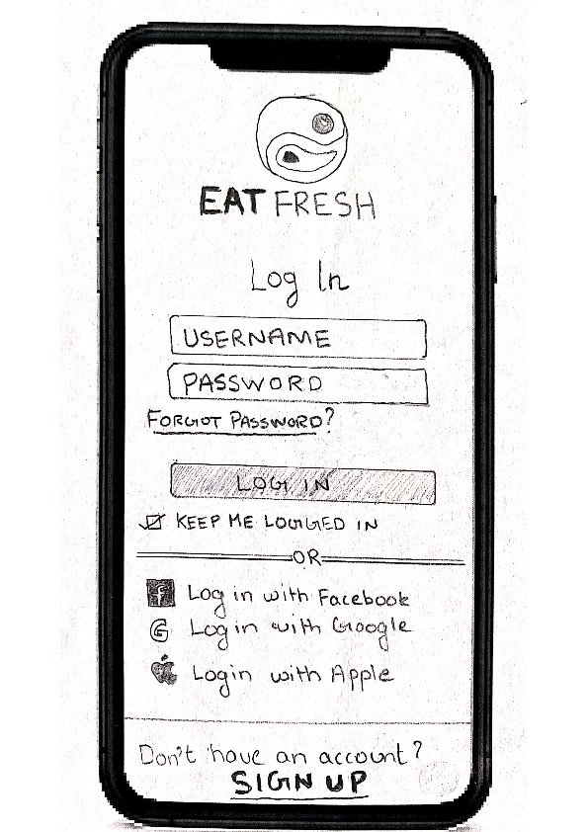

The login page is the first page which the user is taken to, when he/she opens the application.

The page shows the logo of our healthy eating application **EAT**FRESH.

The page requests the user to input the username and password. There is also an option to retrieve user account by clicking ‘Forgot Password?’

There is also an option to sign in from either Facebook, Google or Apple.

While some users might be first time users, an option to ‘Sign Up’ is also provided to the user which helps them create a new account. It is separated using the OR separator.

Figure 1.1.1.1: Log-In Page

### 1.1.2 Title: Sign Up Page

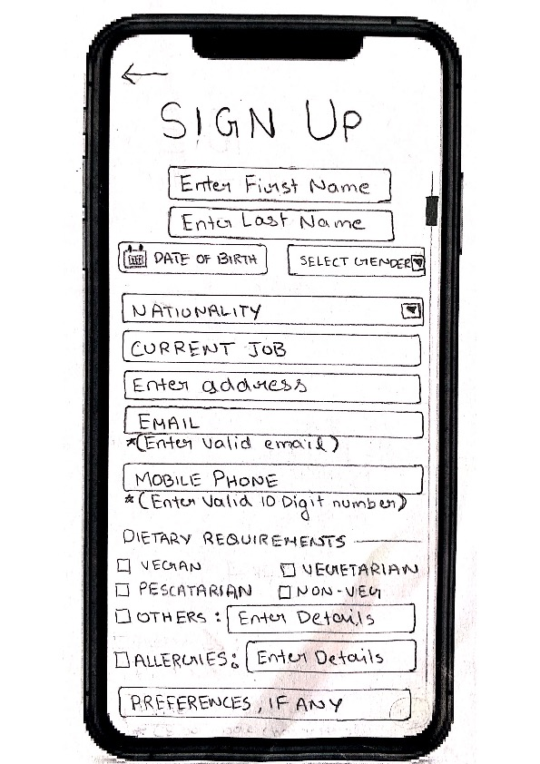

Figure 1.1.2.1: Sign-Up Page 1 Figure: 1.1.2.2: Sign-up Page 2

The Sign-Up Page comes up if the user taps on sign up in the login page.

The page starts off with the title of the page as Sign up. It asks the user to enter his details like first name, last name, date of birth, gender, nationality, current job, email, mobile, dietary requirements, allergies and preferences (as mentioned in the question).

For the password, an added confirm password tab is placed to double check typed password. For higher strength passwords can be forced to be 8 ore more characters. Also, a password that doesn’t match with its counterpart will be highlighted with a ‘password doesn’t match’ message.

## 1.1.3 Title: Find Your Account Page

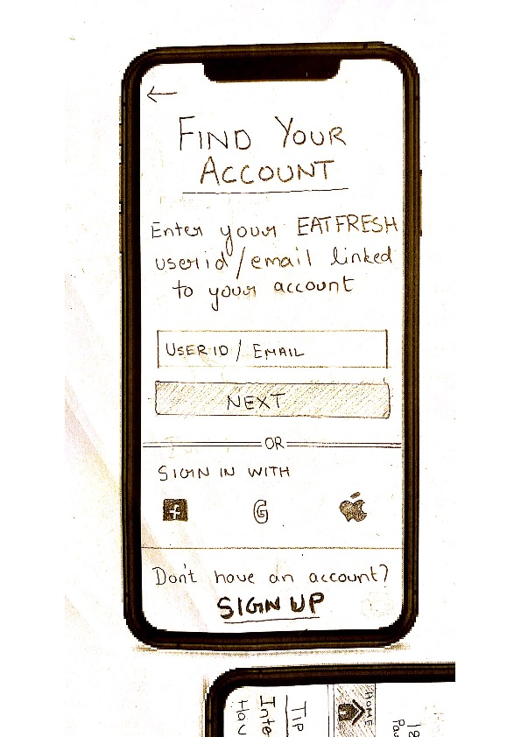

The First Log-in page has a forgot password which is a tappable element on that page. Tapping on it gets you here, to the ‘Find your Account Page’.

The Page tells the user what they have to do to get access to their accounts back.

It asks the user to input the username or the email attached to the account in order to locate it.

This page also gives the user the ability to sign in with the additional third-party accounts, as given in the log in page. And also, the option to sign up if the user feels the need to create a new account at this step of the process.

Figure 1.1.3.1: Find your Account Page

### 1.1.4: Title: Access Account Page

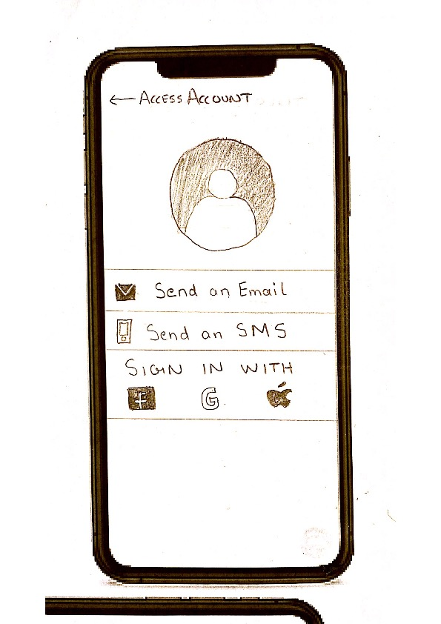

This page comes when the user taps ‘NEXT’ on the Find your Account Page.

Here, since the user has typed their username or email id, the user profile picture can be also be seen.

The user has multiple options like Sending an Email or a SMS to the contacts linked with the account to retrieve them or also to sign up with third party if the user feels they can’t access their devices with logged in credentials.

Figure 1.1.4.1: Access Account Page

### 

### 1.1.5: Title: The Home Page (With and without Tip of the day)

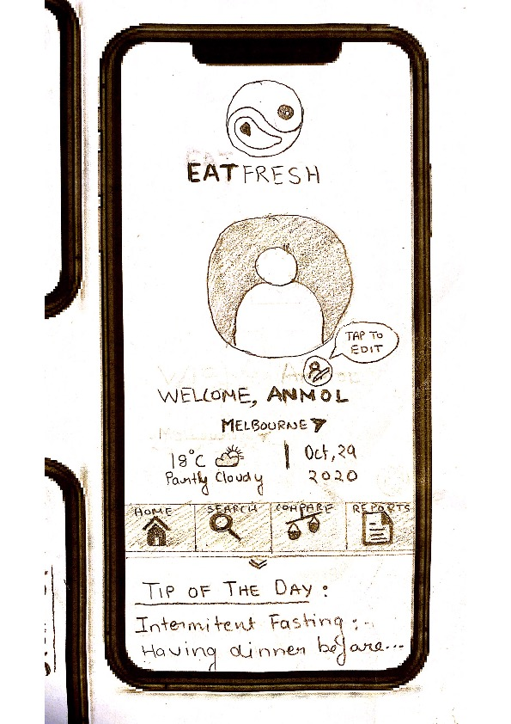

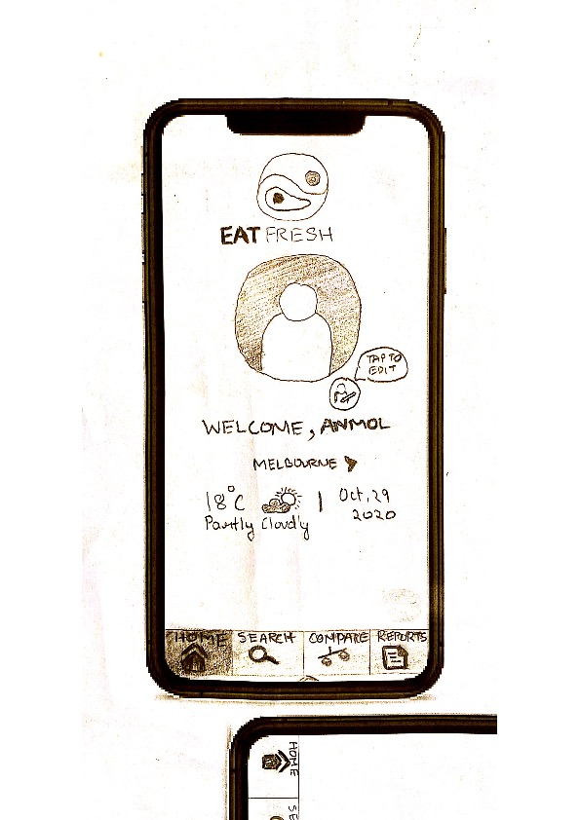 Figure 1.1.5.1: TIP of the Page. Figure 1.1.5.2: Home Page

The home page is page the user logs into first i.e. The page the user sees first when they log in to their accounts.

The page displays the Logo at the top and the user profile picture in the middle just below it. The picture has a small edit icon next to it with a message for the user on how to edit the profile picture.

As asked in the specifications, a personalized welcome message with the users name in it. Below it are some vital information about the day like the weather and the date (asked by the question).

Below is the main control navigation bar which helps the user traverse through the main four features of the application.

A TIP pf the day message appears on a hovering tab which can be swiped down.

## 1.2 Multi-criteria Search Recipes

### 1.2.1 Title: Search Page 1

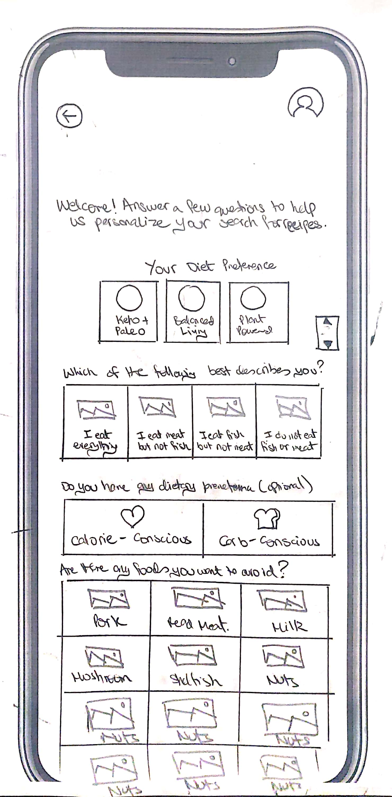

This page comes when the user taps ‘Search Tab’ on the main navigation bar. The page firstly asks the user if he/she has any diet preferences. The user could select any of the three given options. The user is further asked to describe his/her likes, preferences and any food that he/she wants to avoid. Each tab on the page has its corresponding image to depict what the user is selecting.

Figure 1.2.1.1: Search Page 1

### 1.2.2 Title: Search Page 2

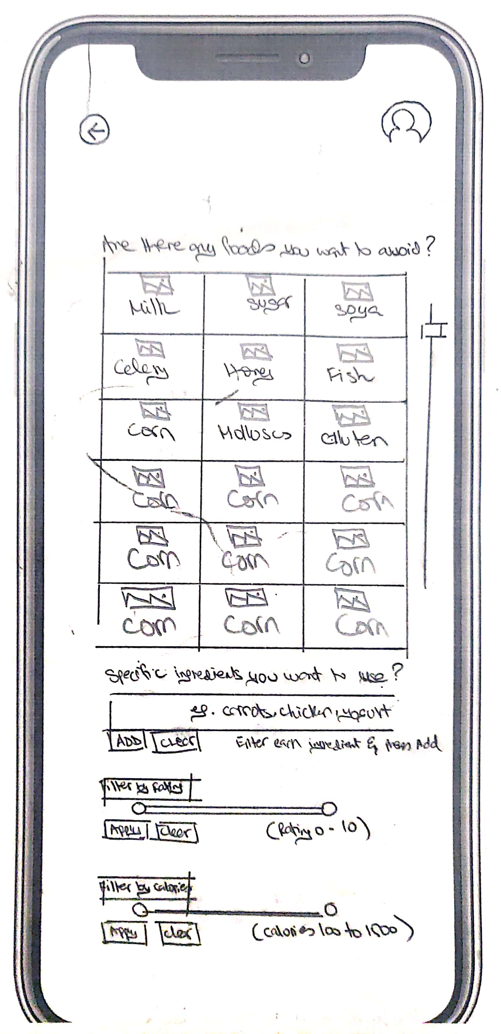

Once the mover scrolls the screen down, the page continues to ask if there are any specific ingredients that they want to use. The user can enter each ingredient and press add for the ingredient list to fill. Moreover, the user has the option of two filters, naming; filter for rating and filter for calories. The user can set his/her desired requirements in both the filters and press apply. Furthermore, the user also has the option of clearing his/her filters by simply pressing the clear button.

Figure: 1.2.2.1 Search Page 2

### 

### 1.2.3 Title: Search Page 3

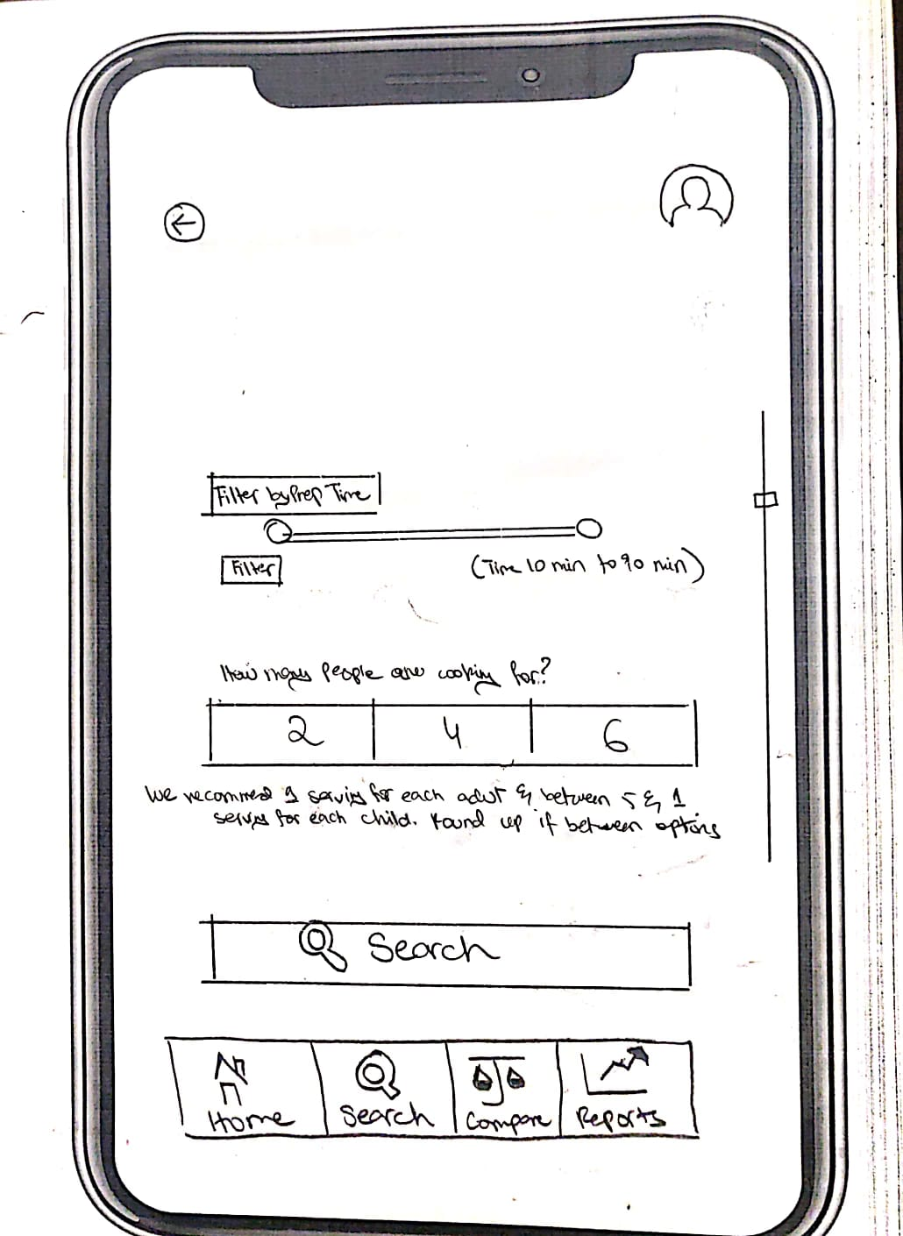

By further scrolling down the screen, the user is shown another filter by the name of ‘Prep Time’. The user can input the time he/she wants to allocate to the preparation of the dish. Same as the above filters, this filter can be cleared with just one click. Lastly, the user is asked how many people he/she is cooking for. The user is giving three options of “2”, “4” and “6”. The user can easily click the required tab and finally click on the search button below once done, that would take the user to the matching recipe page. Moreover, it is to note, the user always has the option of going back either through the back icon on top of the screen or by clicking the navigation tab below in the end of the screen.

Figure: 1.2.3.1 Search Page 3

### 1.2.4 Title: Matching Recipe Page

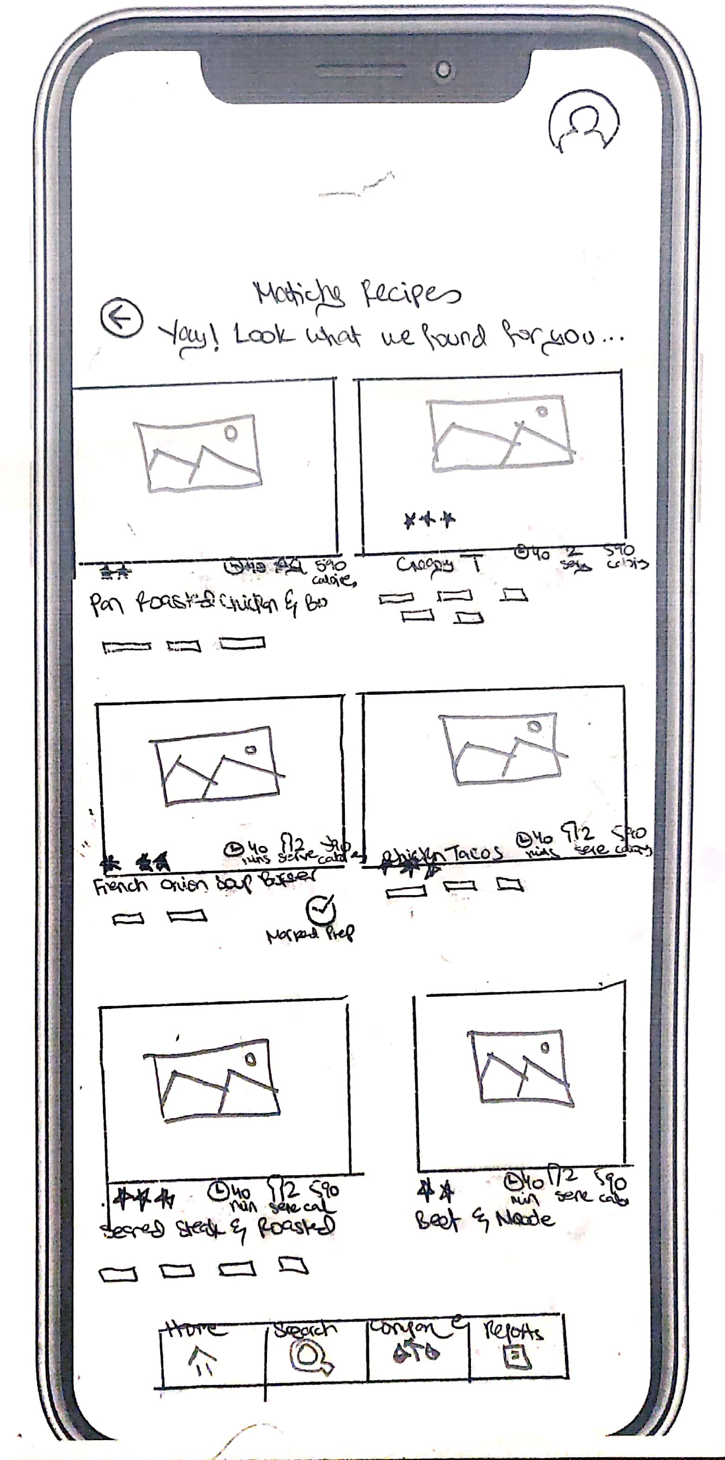

The “Matching Recipe” page depicts the recipes that match the user criteria. Each recipe is shown in separate boxes with its image, star ratings, number of minutes required to make the dish, servings and number of calories. The dish’s name is shown un the image along with the user ingredients or choices that he/she had previously selected to illustrate the matching choices.

Figure 1.2.4.1 Matching Recipe Page

### 

### 1.2.5 Title: List of Recipe Page

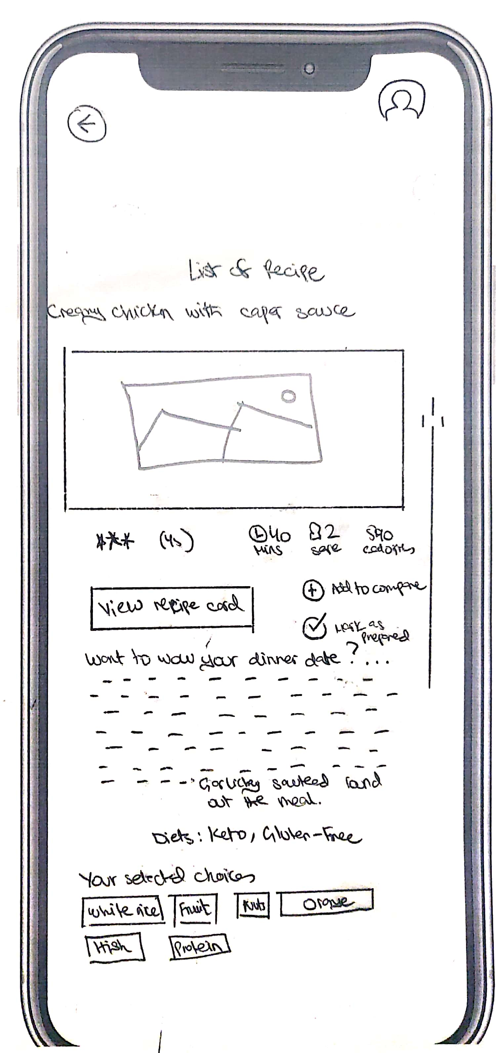

Once the user taps the box of required recipe from the “List of recipes” he/she would be taken to that recipe’s specific page. The page would have the recipe’s picture along with its star ratings, number of minutes required, serving size and the calories associated with that specific dish. There are two icons that are displayed below the calorie section, ‘Add to Compare’ and ‘Mark as Prepared’. The user has the option of comparing recipes by simply clicking on this icon which would take the user to the ‘compare screen’. Moreover, the user as the option of selecting the ‘Mark as prepared’ icon if the user wishes to mark the given recipe as prepared. Those recipes that had already been prepared would further be illustrated in the reports section and would be explained in detail in that given section.

The screen shows a box of “View recipe Card.” “View recipe card” section would be explained in the next screen below. Moreover ‘List of Recipe’ also illustrates a small description under the ‘View recipe card’ icon. Diets, previously selected by the user are also named in bold. Below this section, ‘Your selected choices’ illustrates the ingredients or chosen preferences previously selected by the user. This would make it easy for the user to understand as to what options he/she had previously chosen. After scrolling down on the same screen, the user would be displayed the screen as per below:

Figure 1.2.5.1 List of Recipe Page

### 1.2.6 Title: List of Recipe Page 2

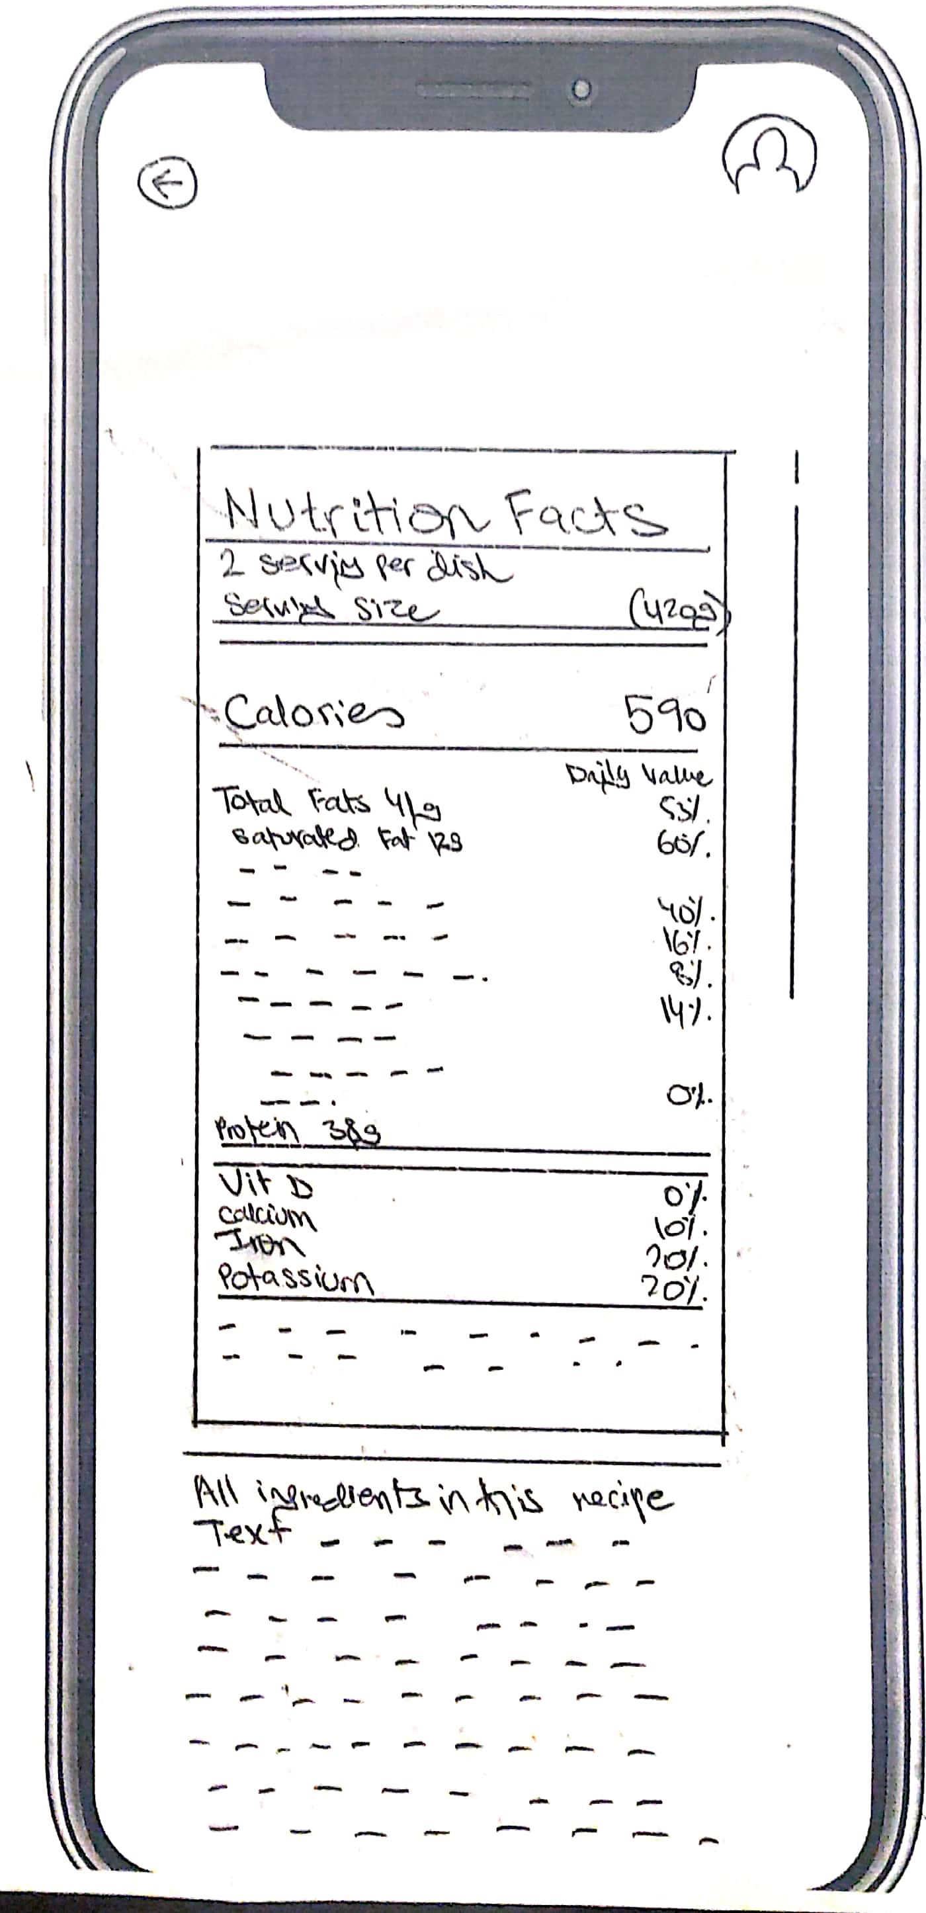

The list of recipe screen further depicts the Nutrional facts of the recipe along with all the ingredients needed in this specific dish. When the user clicks on “View recipe card” as mentioned above the user would be taken to the screens illustrated below:

Figure 1.2.6.1 List of Recipe Page 2

### 1.2.7 Title: Recipe Card Page

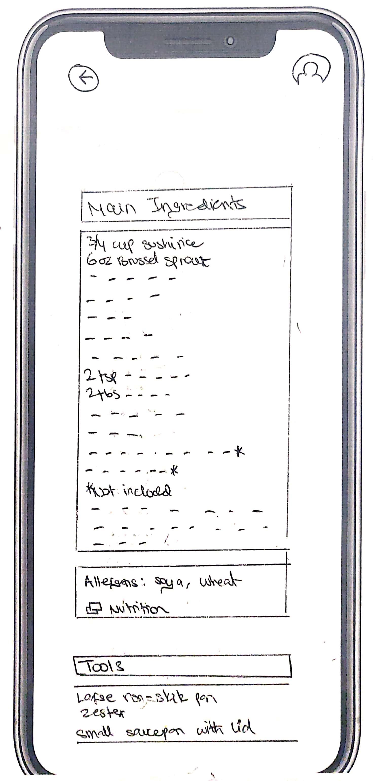

"View recipe card” would illustrate the main ingredients of that specific recipe that was previously selected. The screen would also illustrate the allergens and tools needed to make the given recipe.

By scrolling down the screen above, the user would be taken to the screen illustrated as below:

Figure 1.2.7.1: Recipe Card Page

### 1.2.8 Title: Recipe Card Page 2

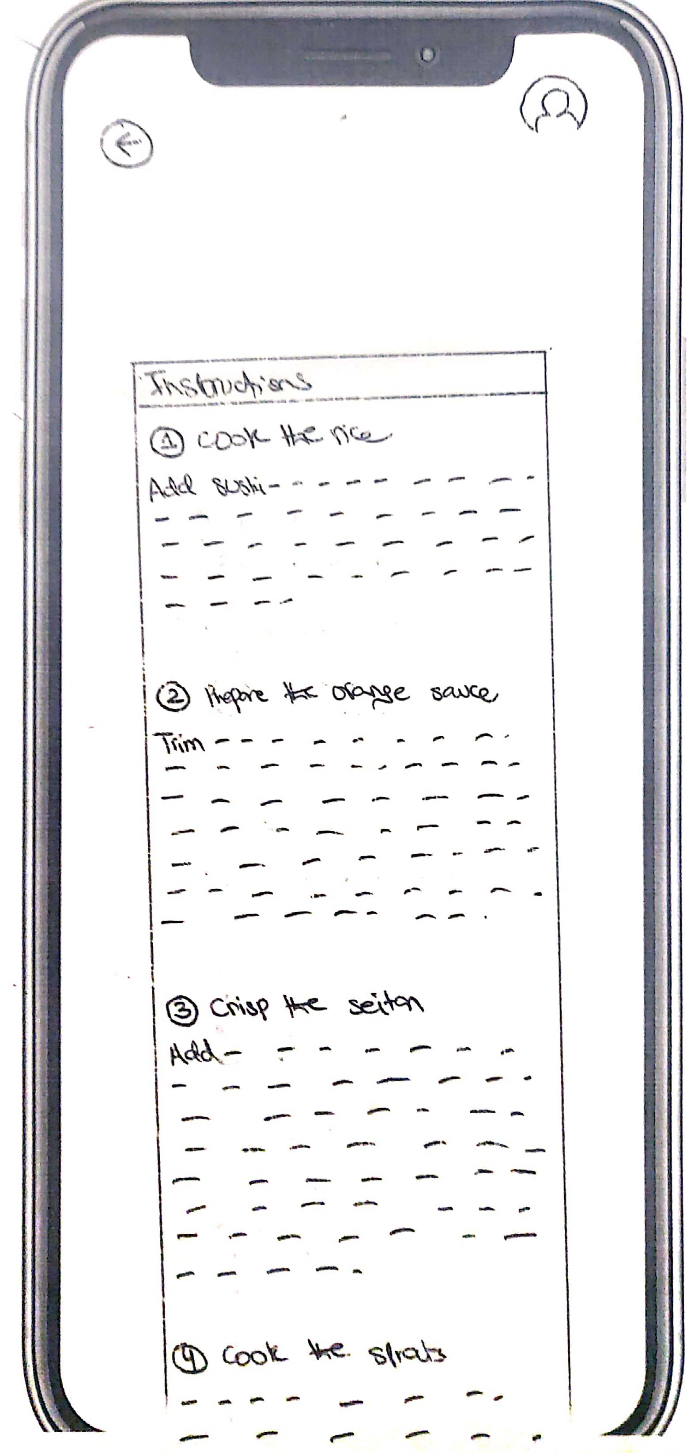

This is the same screen as “View recipe card” screen. The user would be shown instructions once he/she scrolls down from the previous screen showing ingredients and tools required for the recipe. The instructions of the recipe would be given in points with a detailed text explaining what needs to be done.

Figure 1.2.8.1: Recipe Card Page 2

### 1.2.9 Title: Recipe Card Page 3

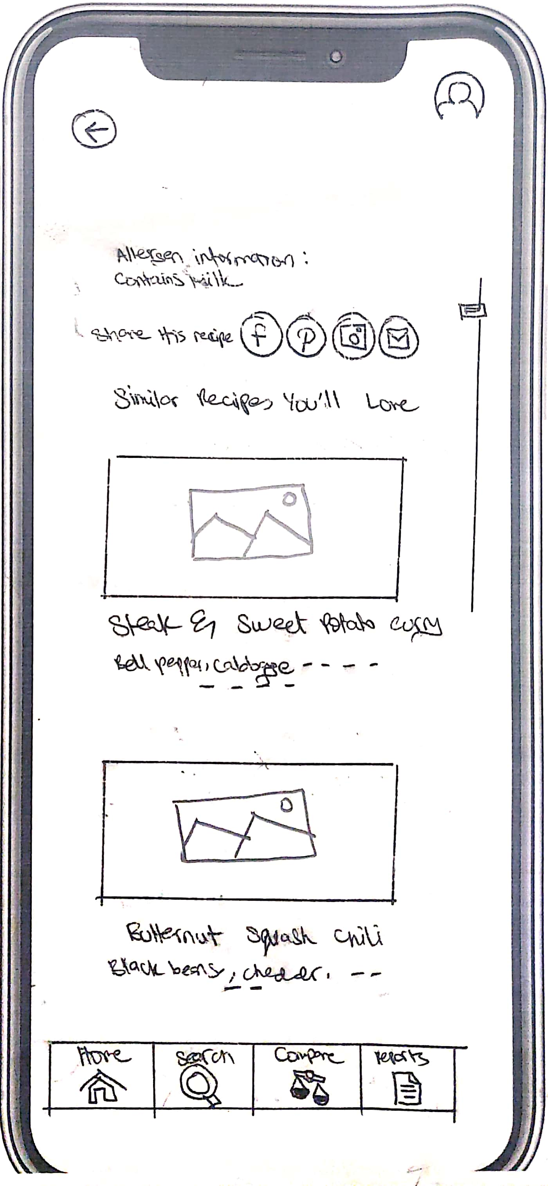

Lastly the user would be given the option to share the recipe. Simply icons are displayed for the user to select and be re-directed to the given app. In our case, facebook, pintrest, instragram and email are the available options for the uesr. Moreover, the user is illustrated similar recipes that they might love. These recipes as illustrated above are like user preferences as selected before. The user could simply click on the similar recipe he/she wished and thus would be directed to that page accordingly. Lastly this page has the navigation bar on the bottom which gives options for the user to go to ‘Home,’ ‘Search’ ‘Compare’ and ‘Reports’ pages, respectively.

Figure 1.2.9.1: Recipe Card Page 3

## 1.3 Comparison

### 1.3.1 Title: Main Comparison Page

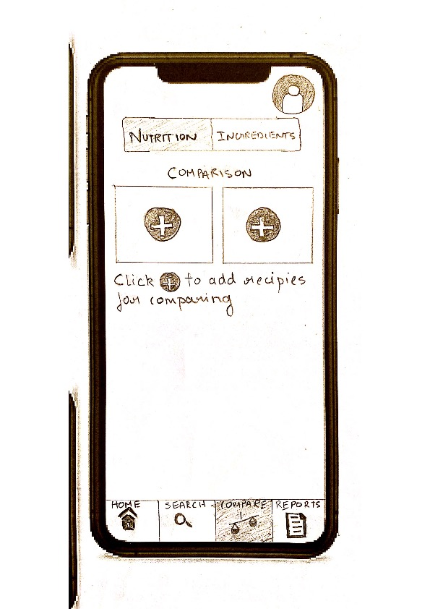

When the user taps on the compare tab in the Navigation bar, the application takes to user to this Comparison Page. Here, the user can compare two dishes in terms of certain categories, which will be discussed further in the next screen.

An instruction in terms of ‘Click the + sign to add recipes for comparing’ is given which tells the user what he/she has to do on this page.

Above, a categorization of Nutrition and ingredients is done which is a slider button like a switch.

There are two boxes with ‘+’ signs which signify that the recipes can be added by clicking on them for them to be added for comparison.

## 

Figure 1.3.1.1: Main Comparison Page

### 1.3.2 Title: Filled Comparison Page - Nutrition

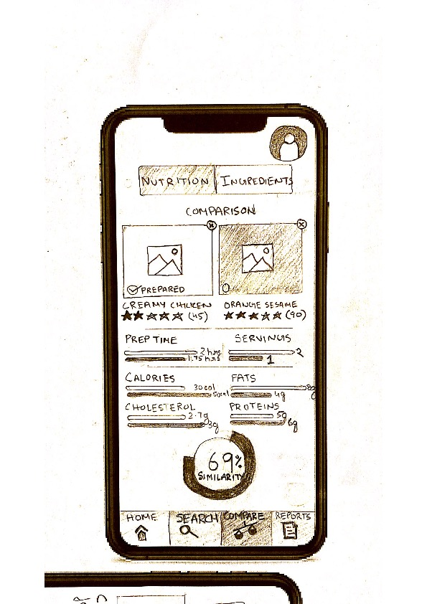

This page appears when the user has added two recipes to the comparison page. Hence it is named as filled Comparison Page.

It has the same Nutrition à Ingredients switch tab which works with “Swiping” the screen.

The Page shows the two pictures of the compared recipes with an option to cancel them (Top right).

Below the Pictures are their ratings (Stars out of 5).

The main comparison is done based on

1. Prep time
2. Servings
3. Calories
4. Fats
5. Cholesterol
6. Proteins

At the end of the graph bars, the respective nutrition value is given for more knowledgeable users.

Colour coded bars represents the comparisons. Based on these comparisons a percentage comparison sphere gives the user a similarity percentage.

Figure 1.3.2.1: Filled Comparison Page - Nutrition

### 1.3.3 Title: Filled Comparison Page – Ingredients

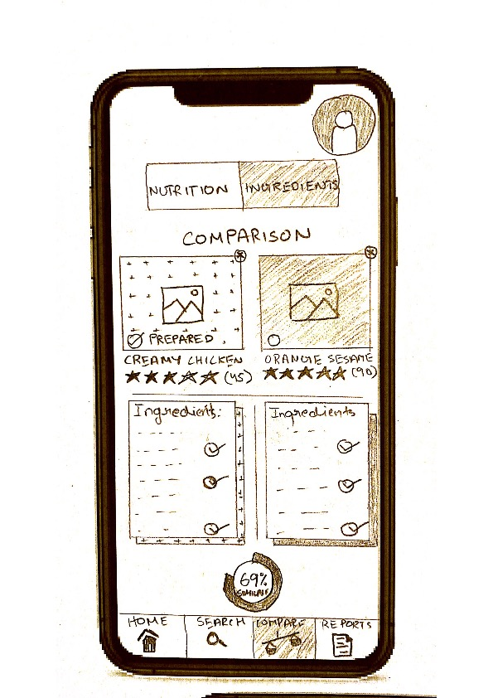

When the user slides the nutrition à Ingredients tab, the application jumps to this page. Here, some elements are the same from the Filled Comparison page – for Nutrition. For example, the colour Coded pictures with their titles and ratings remain same.

The option to cancel them is given by the cross signs on the top right of the embedded picture of the dish.

Below that are the list of ingredients the chosen dishes use and beside them are ticks for the common ingredients between the two dishes. This helps determine the similarity percentage.

The usual navigation tab and the similarity sphere are present on the screen

Figure 1.3.3.1: Filled Comparison Page – Ingredients

## 

## 1.4 Reports

### 1.4.1 Reports Page 1

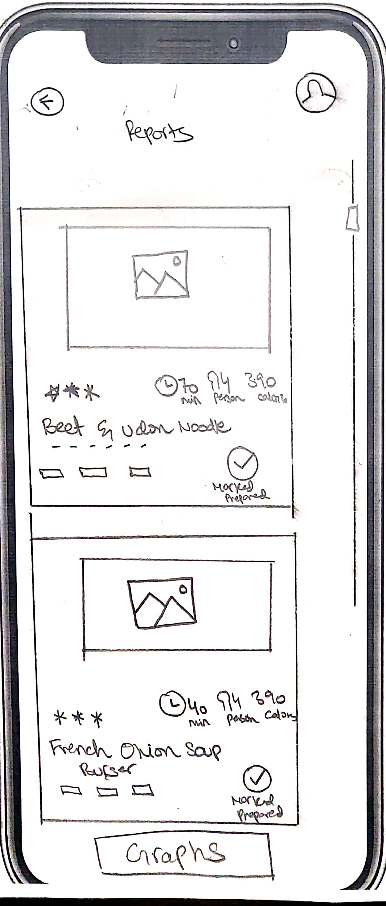

When the user clicks the reports tab on the extreme right side of the navigation bar below of the screen, the user would be directed to the reports section of the app. The report section would allow the user to view the list of recipes that have previously been made/used. Furthermore, it will enable the user to see star ratings as depicted with every recipe. Number of minutes needed for the dish along with the dishes' serving size and calories are clearly mentioned for every recipe. Please note, ‘Mark Prepared’ icon and text appear in these pictures. These are those dishes that the user has previously made/used. The small tabs as explained below the main dishes' heading are the preferences and ingredients that depict the user input previously done in the preference page.

Figure 1.4.1.1: Reports Page 1

### 1.4.2 Daily Graph Page

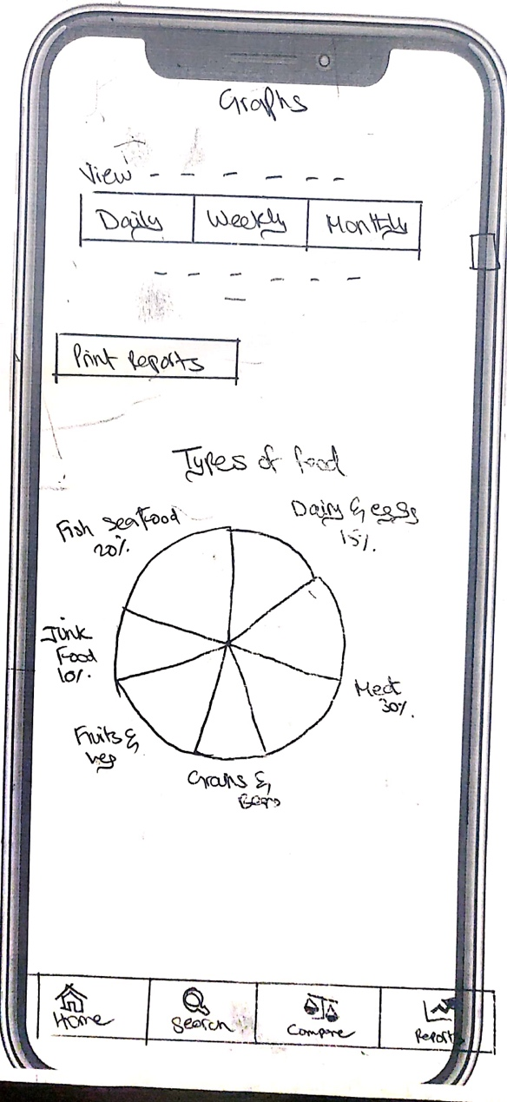

When the user clicks the graph icon on the reports section screen, he/she is taken to the graphs section of the app. This allows the user to view periodic (daily, weekly, and monthly) eating habits reports as graphs and pie charts. The first ‘Type of food’ pie chart illustrates the several types of food that the user consumes. The categories mentioned are junk food, fruits and vegetables, grains and beans, meat and poultry, fish and seafood, and dairy. If the user scrolls down the same screen he/she would be directed to the screen below:

Figure 1.4.2.1: Daily Graph Page

### 1.4.3 Daily Graph Page 2

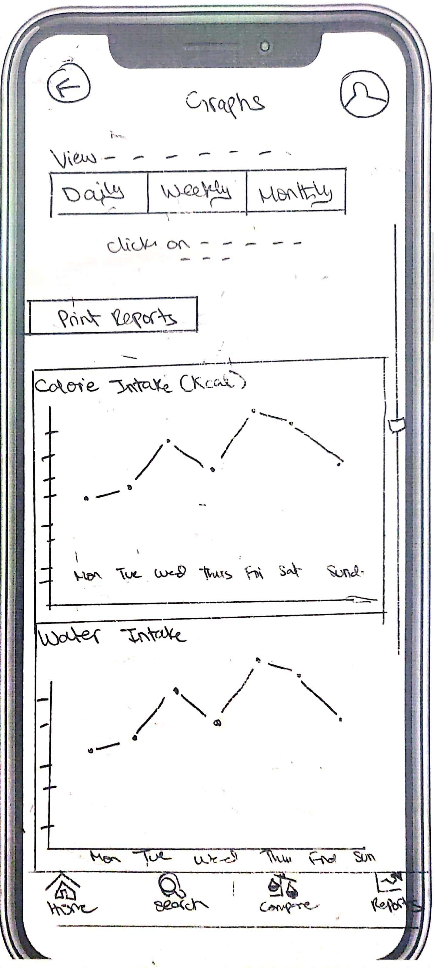

Furthermore, the user would be shown two graphs, one depicting the calorie intake and the second illustrating the water intake of the user. Please note the user has options of viewing such reports in ‘Daily’, ‘Weekly’ and ‘Monthly’ formats by simply clicking on the tabs on top of the graph screen. Moreover, keeping the design consistent, the user is given the navigation bar on bottom of each screen as illustrated above.

2. Digital Prototype:

Digital prototypes are high fidelity prototypes. High fidelity prototypes are computer/software-based prototypes that are much closer to final application than low fidelity prototypes. High fidelity prototypes concentrate more on the look and feel and the colour pallet of the application. Although they are close to the final product, they aren’t fully functional and only entails the page linking aspect of application building.

We have done our high fidelity prototyping on Figma.

Figure 1.4.3.1: Daily Graph Page 2

## 2.1 Sign in/Sign up Page

### 2.1.1 Login Page 2.1.2 Sign Up Page 1

Figure 2.1.1.1: Login Page Figure 2.1.2.1: Sign-up Page

Figure 2.1.3.1: Sign Up Page 2 Figure 2.1.4.1: Sign Up Page Successful

### Graphical user interface, application Description automatically generated2.1.5 Retrieve Account 2.1.6 Access Account

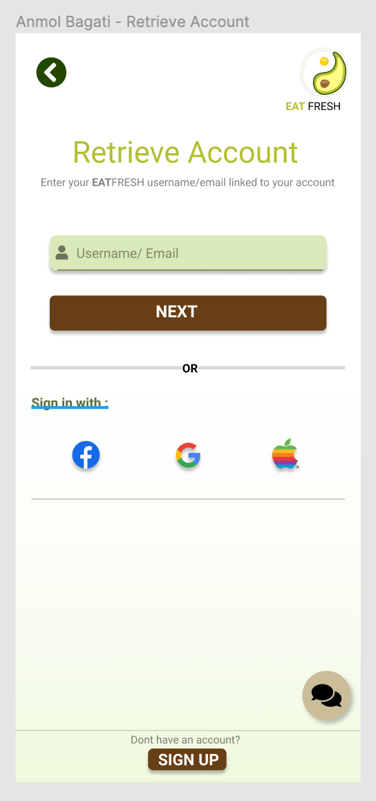Figure 2.1.5.1: Retrieve Account Figure 2.1.6.1: Access Account

### 2.1.7 Welcome Page with Tip of the Day 2.1.8 Home Page without Tip of the Day

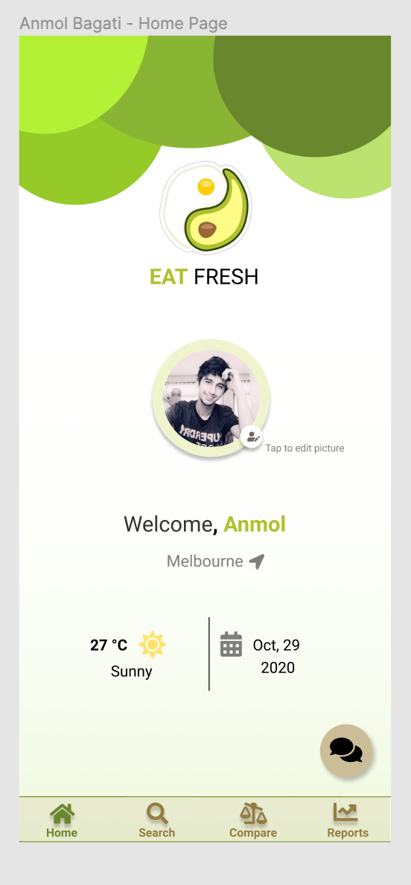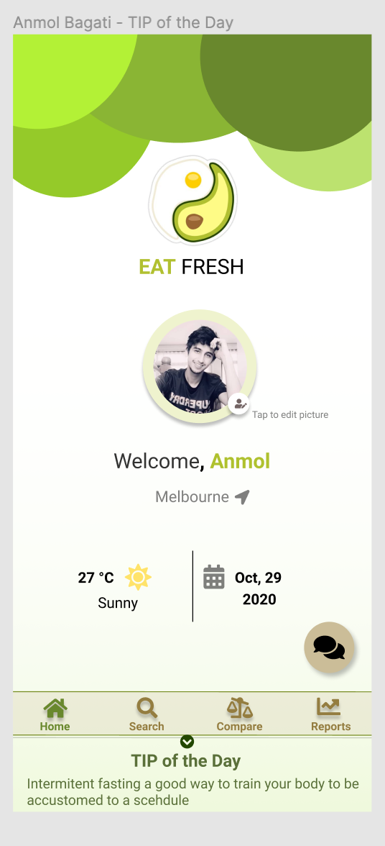

Figure 2.1.7.1: Welcome Page w TIP of the Day Figure 2.1.8.1: Home Page w/o TIP of the Day

## 2.2 Multi-Criteria Search Recipes

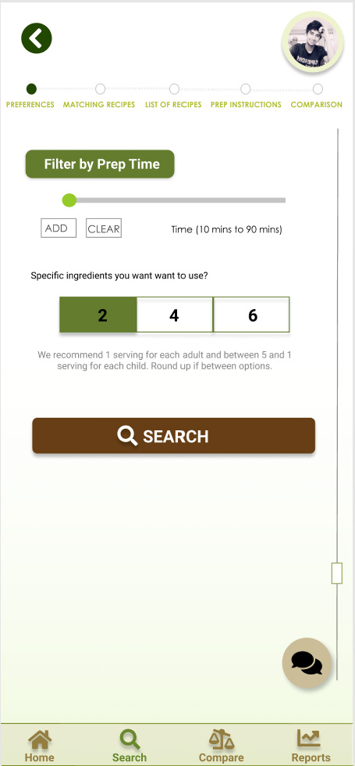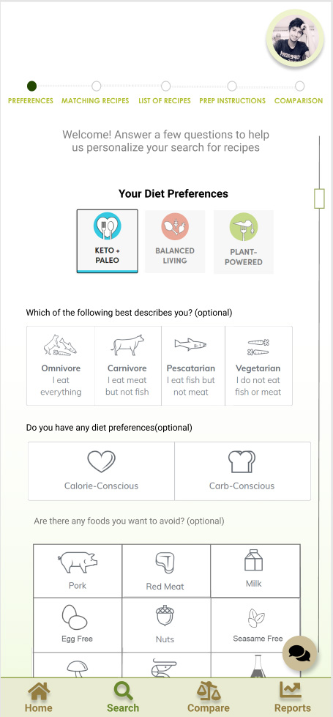

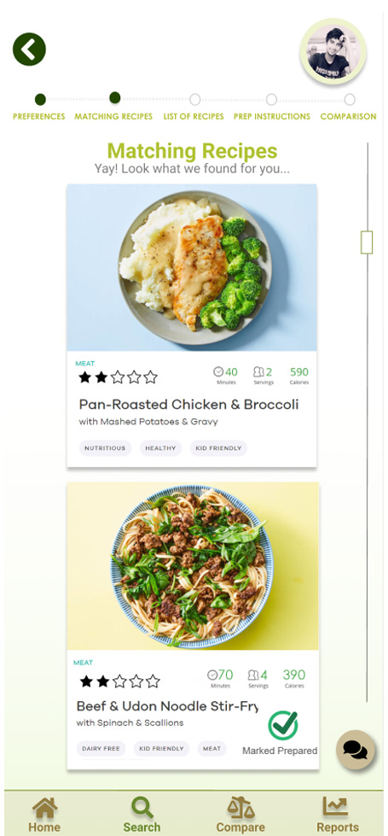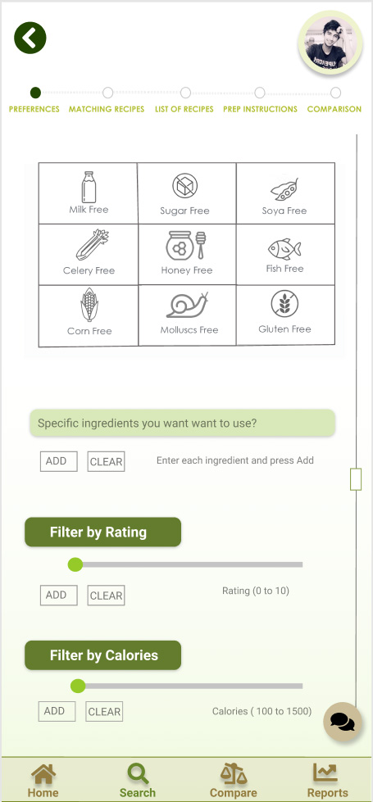

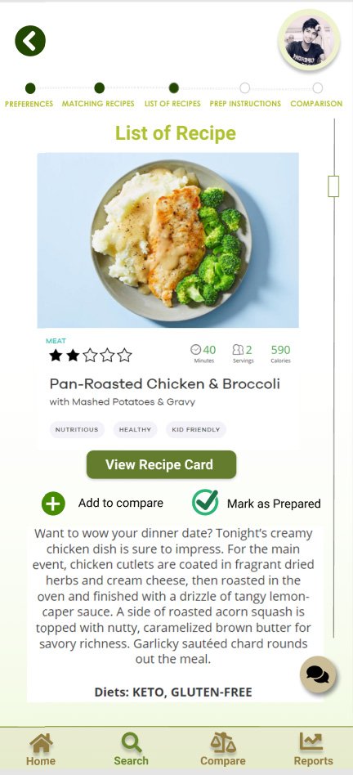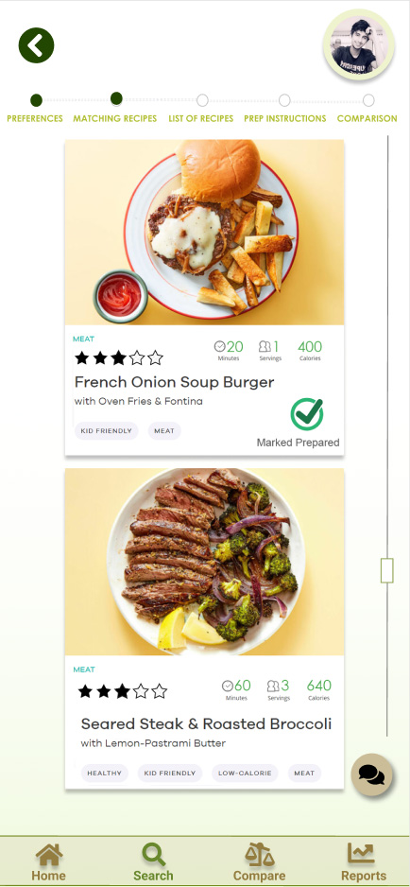

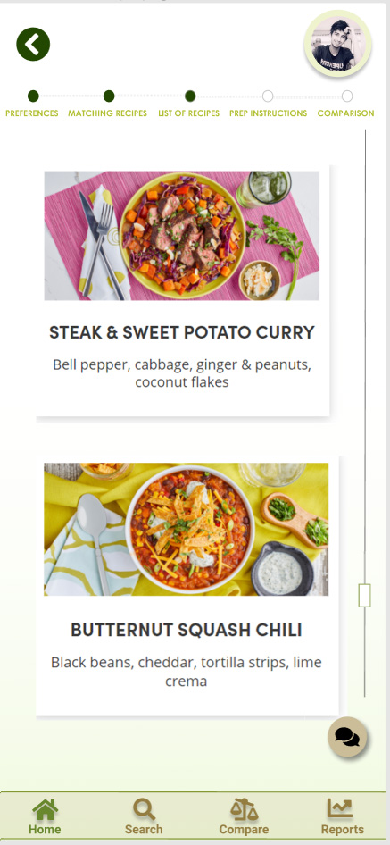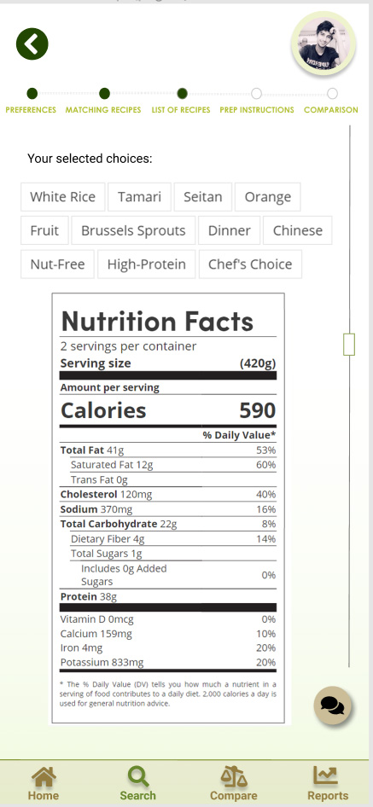

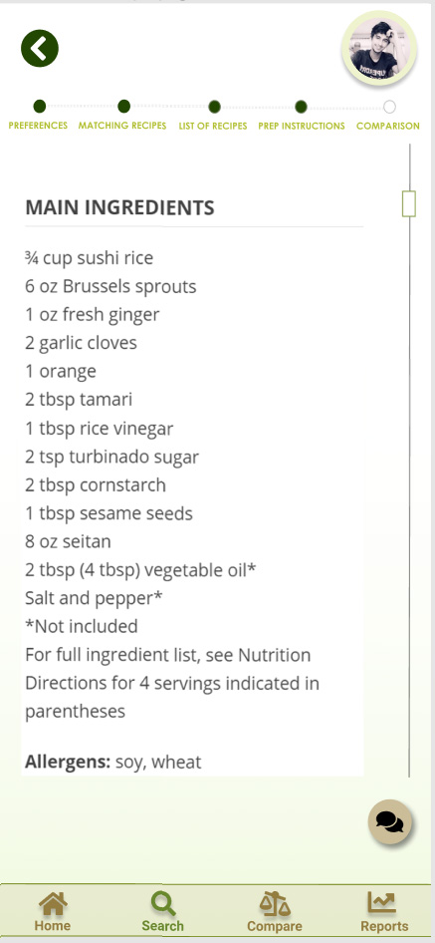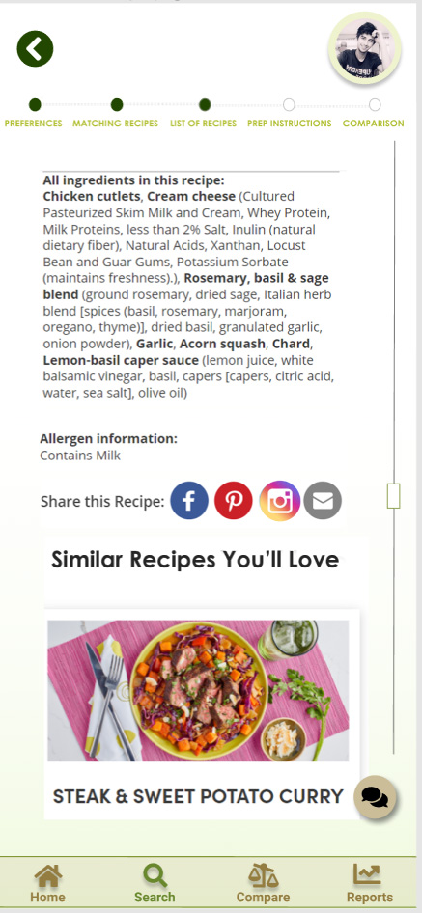

## 

## 

## 2.3 Comparison

### 2.3.1 Comparison Main Page 2.3.2 Semi- filled Comparison Page 1 - Nutrition

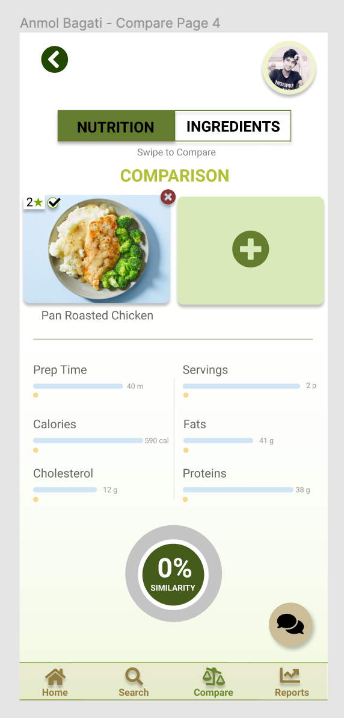

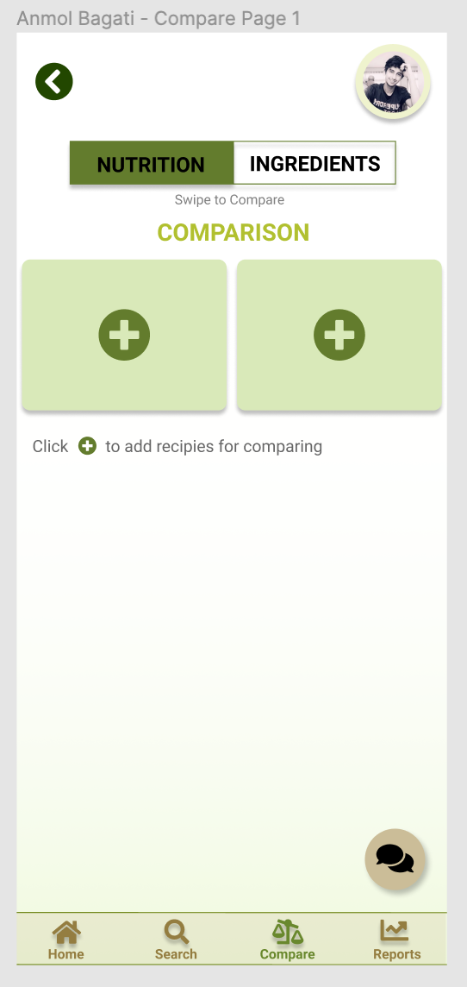

Figure 2.3.1.1: Main Comparison Page. Figure 2.3.2.1: Intermediary Semi filled Comparison

### 2.3.3 Semi- Filled Comparison Page 2 – Nutrition 2.3.4 Fully Filled Comparison Page – Nutrition

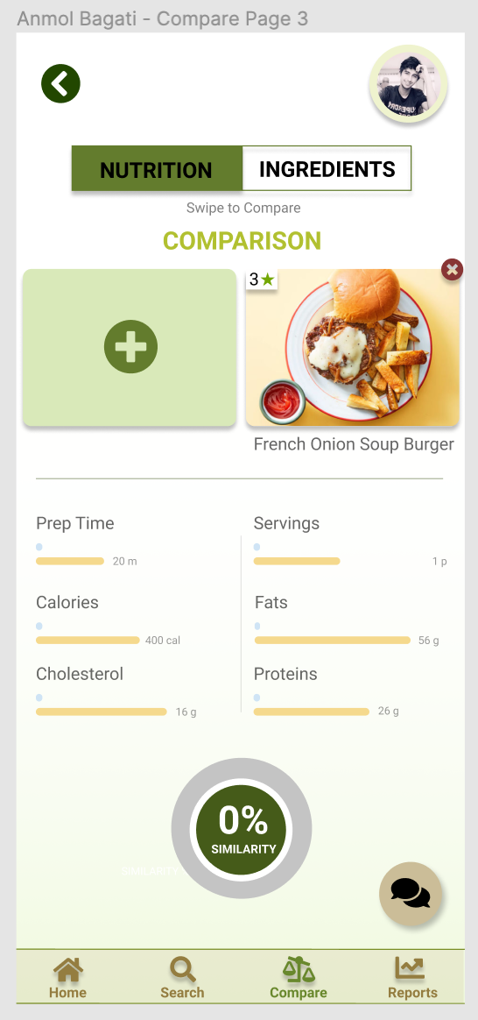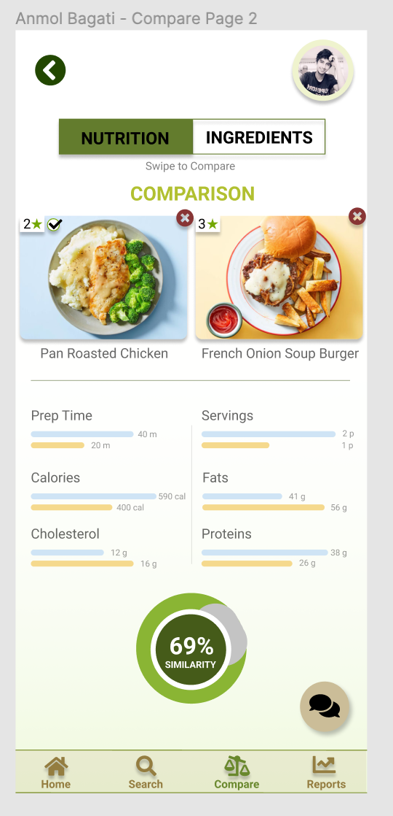

Figure 2.3.3.1: Intermediary Filled Comparison Figure 2.3.4.1: Completed Comparison Page- Nutrition

### 2.3.5 Comparison Page – Ingredients

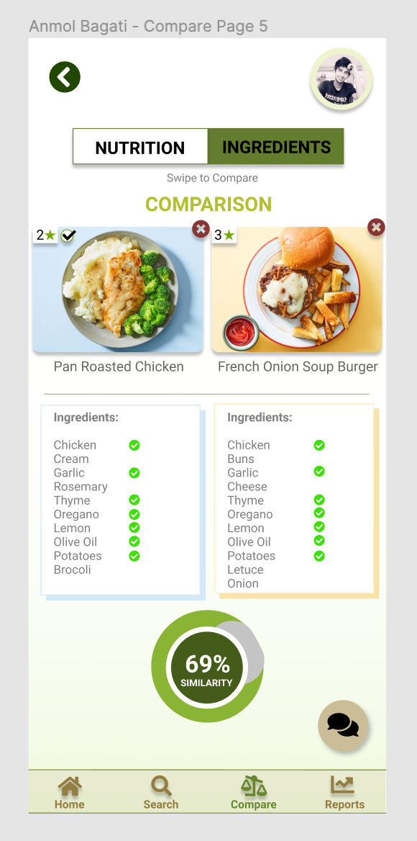

Figure 2.3.5.1: Comparison Page – Ingredients

## 2.4 Reports

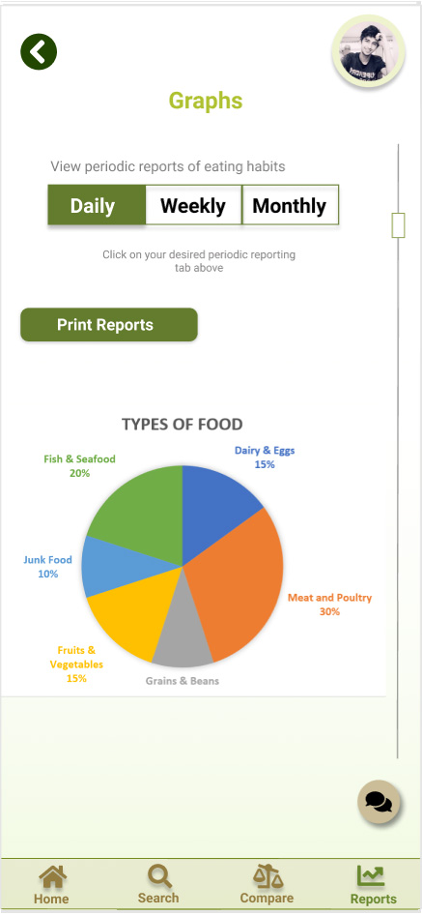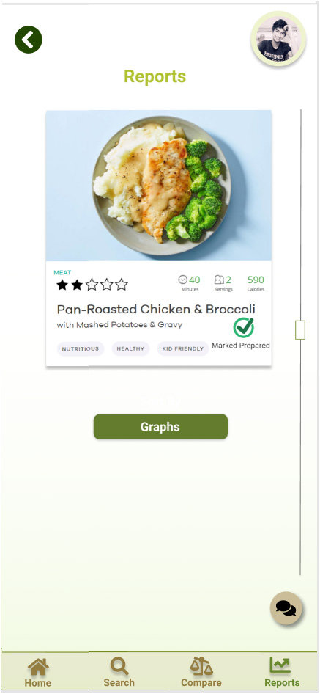

# 

# 

# 3. Changes Between High and Low fidelity Prototypes

## 3.1 Sign In/ Sign Up Pages – Icon Signifiers

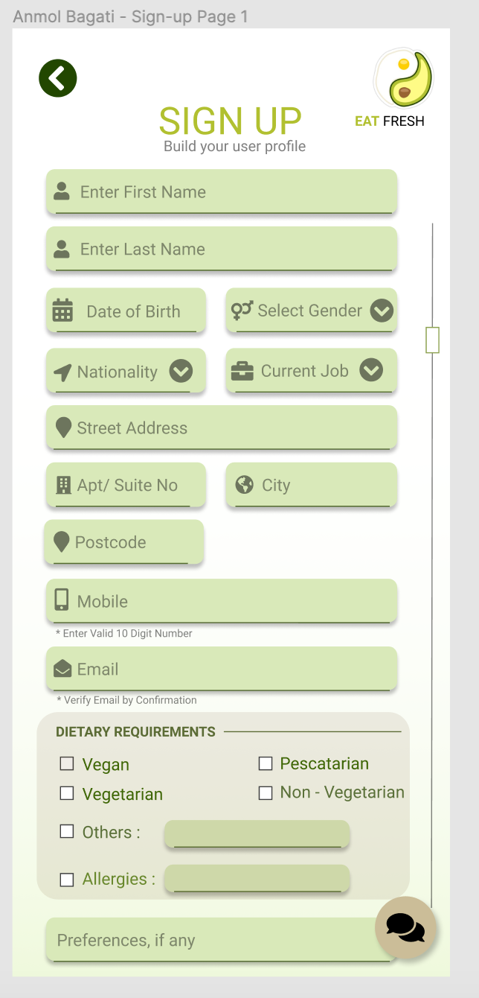

It can be clearly seen that icon signifiers placed in front of each user input, increase usability through increasing ease-of-use of the application. Those icon signifiers are missing in the low fidelity diagram.

## 3.2 Sign up/Sign in and Compare Pages





There are times we have to understand that the user might be unaware of why he/she is on a particular page. Also, a user might know of tapping on a button but not be aware of the swipe/slide action. Hence a one liner below the title of the page to give user an overview of the task at hand.

Similarly, in the below image in the sign up and sign in/Login page, a small one liner subtext helps user know of the main goal of that particular page.

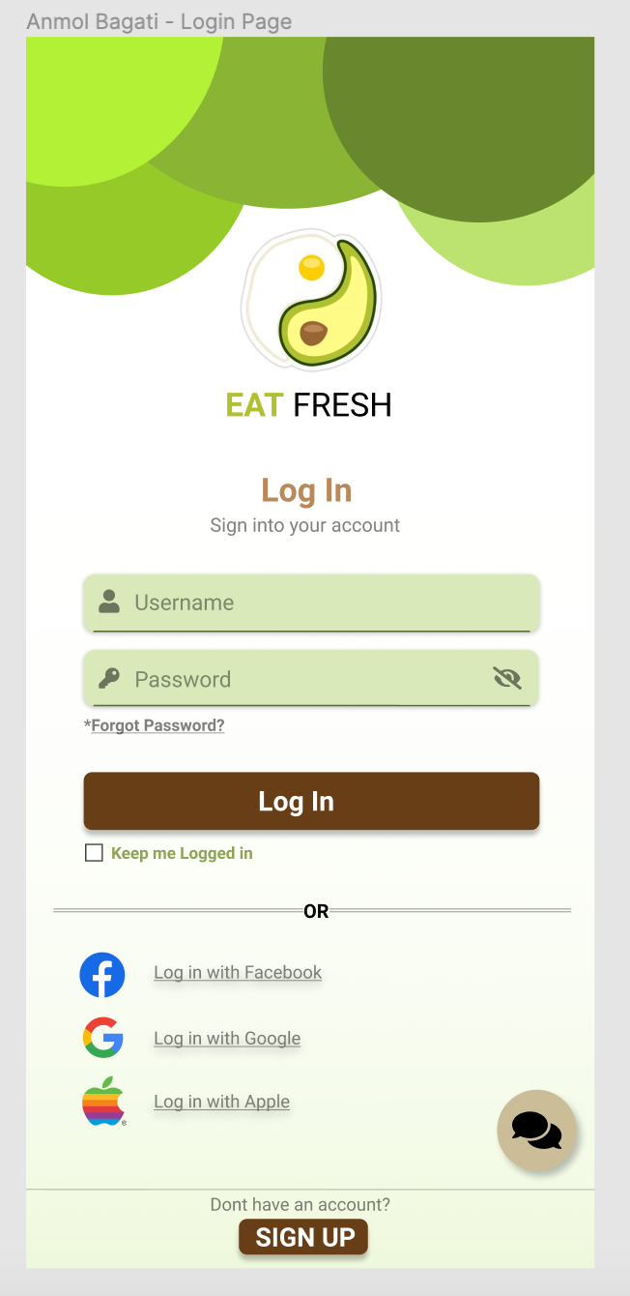

Their counterparts in low fidelity diagram miss these important components, as shown below





## 3.3 & 3.4 Multi-Criteria Search

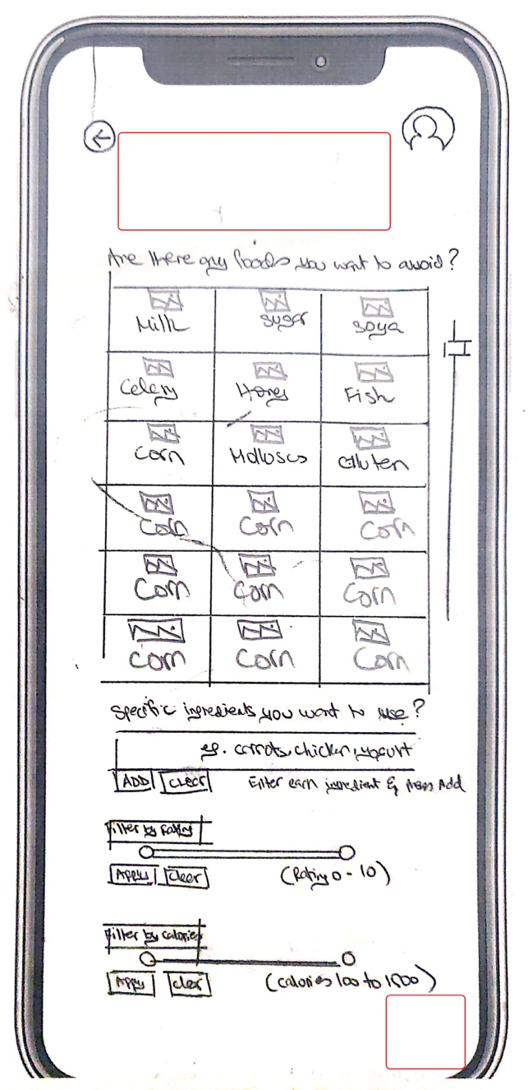 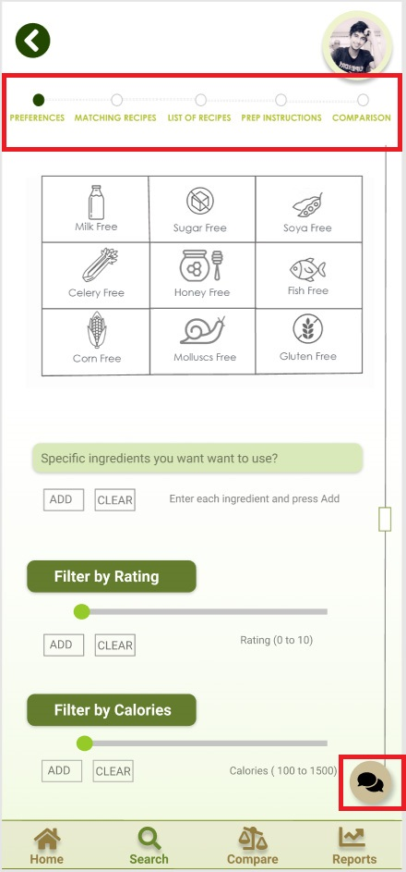

Please note in the low fidelity diagram on the left, I had not included chat box and a navigation bar on top of the preference screen. Even though there is a navigation bar showing ‘Home’, ‘Search’, ‘Compare’ and ‘Reports 'on the bottom of the screen, I realised that the user should be given a navigation bar on top of the screen to easily navigate between pages named ‘Preferences’, ‘Matching Recipes’, ‘List of Recipes’, ‘Prep Instructions’ and ‘Comparison’. This navigation bar illustrates the page the user is at. Moreover, when the user goes to the managing page or list of recipe page, you may notice the small green circle to turn green on the actual page the user is at. Furthermore, the user can easily go back to whichever page he/she wants by simply clicking on the green circle that would direct the user to that specific page.

Moreover, I had not included a chat feature in the low fidelity. I believe the user should be given this chat option to ask any questions or queries that he/she might have. This would help the user navigate through the app with ease thus giving full functionality to the app in use. Thus 2 changes are illustrated above that I have made from my low to high fidelity images.

# 

# 4. Design Guidelines being Followed

## 4.1 Sign-In/Sign-up Page

### 4.1.1 Show/Hide Password & Remember Password & Sign in through Social Media



Here, we give the user the possibility to show or hide the password for the account. Giving the user this added functionality of viewing or hiding the typed password helps the user in cases where he/she thinks that they have put the wrong password but don’t want to clear all the characters. User can unhide the password and correct their mistake. This helps better the user experience.

Also, if the user wishes to not remember his/her password and wants to always be signed in, there is a checkbox which can be ticked before logging in once and that will the computer keep the user logged in and avoid the repeated task of signing in. This reduces the load on the users cognitive memory, thus augmenting user experience.

Sign in through social media is another principle to be followed while making sign in forms. This gives the user more options to sign in from which also increases user freedom.

### 

### 4.1.2 Three Principles – Discoverable, Clear, and Efficient



The 3 principles to make sure of in form design are Discoverability, Clearness, and Efficiency.

Discoverability: The text fields are discoverable and indicate that user input is needed. This is done by making tabs like the one indicated on the left. These tabs have shadows in the border which give them a look and feel of an input box.

Clear: Text fields are clearly differentiated from other input boxes and the instruction about what to input is pretty on point and concise.

Efficiency: The icon signifiers help improve the efficiency of the system as it increases the user experience. The address field is split into multiple input boxes as taking targeted inputs is better than asking for vague inputs like address.

### 4.1.3 Feedback – Normans Principle

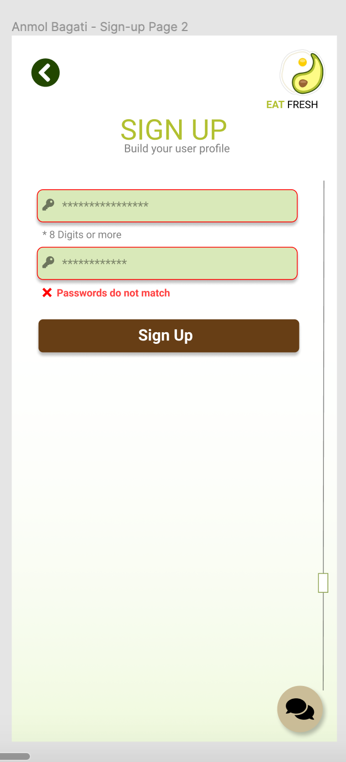

When the password entered by the user in the confirm password input text box doesn’t match the password in the original password text box, then the text box gets high lightened in colour red, apart from the ‘Passwords do not match’ feedback message, which gives the user immediate feedback regarding the situation.

An informative feedback goes a long way to better user experience. This helps user access the situation better and take necessary actions.

## 

## 4.2 Multi-Criteria Search

### 4.2.1 Affordance Principle by Donald Norman



Affordance is the relationship between what something looks like and how it is used. The user needs to quickly know what to do after seeing something and know how to use it. For example, in the image below, the user can easily depict by seeing the filter knobs on both filters named, filter rating and filter by calorie section. The knob easily illustrates that it could be adjusted as to user’s requirements. Thus, the high fidelity illustrates high affordance in usability.

### 

### 4.2.2Flexibility and efficiency of use Principle by Neilson

This principle is about giving the user ways to speed up the work with more efficiency and flexibility. In the image below this principle is illustrated. As you can see the user has been given two navigation bars, one on the top of the page and the other at the bottom of the page. The navigation bar on top illustrates ‘Preferences’, ‘Matching Recipes’, ‘List of Recipes’, ‘Prep Instructions’ and ‘Comparison’. Whereas the navigation bar on the bottom of the page lets the user select ‘Home’, ‘Search’, ‘Compare’ and ‘Reports’.

In high fidelity, high flexibility and efficiency has been illustrated as the user has two options of navigating through the pages by using either of the two navigation bars as shown below.

Minimize the user's memory load by making objects, actions, and options visible. The user should not have to remember information from one part of the dialogue to another. Instructions for use of the system should be visible or easily retrievable whenever appropriate.

### 4.2.3Recognition rather than recall Principle by Neilson

This principle asserts the user’s memory to be used to the minimum, making objects, actions and options visible. Figure below illustrates an icon named ‘Mared Prepared’. Thus, the user does not need to remember information from one part of the dialogue to another. The user can easily recall if he/she has made the recipe before as the icon would easily illustrate. The user would not have to go through each recipes page to verify if he/she has made the recipe before or not. The icon would easily illustrate if the recipe has been made before or not. Thus, the user would not have to recall repeatedly of his/her earlier actions about a recipe.



## 

## 4.3 Comparison

### 4.3.1 Nielson’s Visibility of System Status



Here the tab turns green when it is selected and similarly, when swiped right, the ingredients tab turns green. Hence, the application supports Nielson’s #1 guideline of giving the user the visibility of system status. The system status afforded to the user is in terms of which comparison page the user is currently on. The green nutrition tab indicates that the user in the Nutrition comparison tab.

This helps the user understand the application better and encourage them to use it.

### 4.3.2 Nielson’s - Help and Documentation



The chatbot icon given in the right bottom of the screen helps the user with any of the difficulties it has with the application pages and functions. The chatbot will give the user suitable advice for his/her problem.

For novice users, who haven’t used the application before, or just non- tech savvy people, some functions might be really confusing and they would need help to perform certain functions. An application should have a methods of addressing those problems.

This chatbot helps our application conform to Nielson’s #10 Heuristic of Help and Documentation.

### 4.3.3 Nielson’s Consistency and Standards



The colour in the background of the image is the same as the colour in the bars depicting the comparison of the two dishes.

For example, the dish on the left has a blue background. Hence the two coloured bars has one of them coloured as blue, hence maintaining consistency throughout the page. This helps the user easily spot the corresponding comparison values of the two dishes.

The orange and the blue bars are consistent with its dish.

## 

## 4.4 Reports

### 4.4.1 Typography Principle

Being termed the fundamental principle of a superior design, typography is to be taken into consideration. Good typography helps balance the visual structure of the design between the content and the visuals. Figure below illustrates the matching of all fonts and text sizes. It is easy for a user to depict info through all tabs naming; daily, weekly, and monthly. You may notice that the charts may change but the font and shapes of the charts would not change, thus, making it easy for the user to understand the layout.



### 

### 4.4.1 Match between system and real-world principle by Nielson

The system needs to speak the user’s language, including words, phrases and concepts that are familiar to his/her use rather than using system-oriented terms. We need to follow real-world conventions making sure the information is natural and in a logical order. The figure below illustrates how real-world entities are applied in our high-fidelity image. Graphs depict the real-world entities from statics. Moreover, mathematics has been applied in our graphs section of the reports, thus, making it easy for the user to understand. Pie charts and histograms are depicted as real-world elements that have been translated to their electronic counterparts.

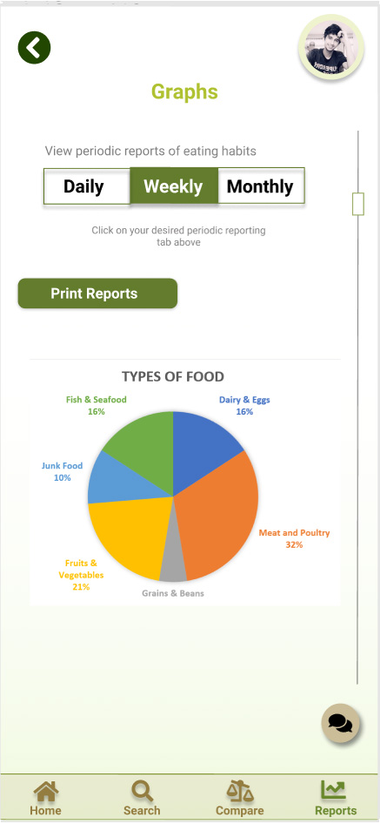

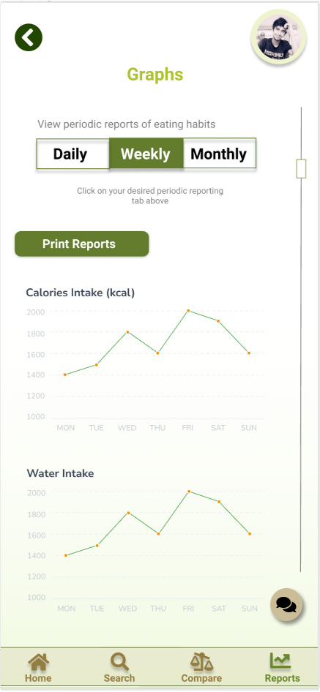

### 4.4.2 Reduce short Term Memory Load principle by Nielson

Like recognition rather than recall, the principal highlights that recognizing something is easier than remember it. We as designers need to make sure the user’s memory is used to the minimum by making objects, actions, and options readily available. Thus, the user should not have to remember information from one part of the dialogue to another. In the figure below, we can see the navigation bar stating ‘Daily’, ‘Weekly’ and ‘Monthly’. Note the graphs have been divided into these three categories in the tabs. The tabs are clickable which lets the graphs and data to be changed from one tab to another easily by just a simple click. Thus, the user does not need to remember where to go for viewing reports and graphs on a weekly or monthly basis. The user can easily navigate all these options through just one page and by just one click. The user does not need to go to any other page to view the data. Thus, the user does not need to use memory.



Daily, weekly monthly, divide the graphs , in terms of tabs that are clickable, move from one to another. The user does not need to remember, navigation easy through one page , simply click and see the data. No need to go anywhere. Memory load less of the user. No use of memory,

# 5 Conclusion

Prototyping is done to understand the ins and out of the final product before actually building it. What prototyping essentially does is lets the developer know of the probable issues or design considerations which he/she have to look after. This results in the developer building a design which is more empathic to the user and their needs.

The low fidelity diagram concentrates more of the rough sketch of the application. It details how the user will traverse through each page in the application. The end product of this step are hand drawn sketches of application pages and our idea of how they should look. The nature of a low fidelity prototype is of crude and not very close to the end product, but none the less has its advantages. It is inexpensive in nature and does not require high end designers. Stakeholder participation in such cases are vital. Although, there are disadvantages to it, for instance, low fidelity prototypes are static in nature and hence the ultimate look and feel is missing. The colour scheme or button design cannot be detailed in a low fidelity diagram.

To overcome these issues, we also build a high fidelity diagram. This helps us overcome the disadvantages of low fidelity prototyping. While making high fidelity diagrams we could conclude that the initial draft made in the low fidelity diagram was far away from the actual product and numerous changes are reflected in the high fidelity diagram. They are more interactive in nature and give us a look and feel of the application. Linking pages help is decide the path of events while using the app. A disadvantage of this prototyping is that even though it is really costly, it doesn’t really get us much closer to the final product.

While using FIGMA, what I could conclude is that, even though it is a high fidelity prototype making software, it has limited options in terms of ways to select an element on the screen. For instance, ‘Tap and hold‘ feature of touch screen phones is missing, which could help us get closer to the final application. Also, form validation i.e. Checking if the password is correct, or if the entered input is just a string of numbers and not characters(in case of phone numbers) is NOT possible on Figma.

# 6 Reference

<https://fontawesome.com/>

<https://www.purplecarrot.com/recipe/orange-sesame-seitan-with-charred-brussels-sprouts-sticky-rice-f294a794-0b81-412e-8483-e088797e6385?plan=chefs_choice>

<https://www.greenchef.com/recipes/keto-cream-cheese-chicken-cutlet-acorn-squash-no-butter>

<https://dinnerly.com/menu>

<https://www.greenchef.com/menus/keto-+-paleo>

<https://www.greenchef.com/menus/main>

<https://www.greenchef.com/sign-up/plan>

<https://www.greenchef.com/menus/keto-+-paleo>